EXPERIMENT 6 — STEP-WISE SOLUTION
Sales and Profit Performance Analysis using Targets and Scorecards in Power BI

PART A: OPEN AND VERIFY THE EXPERIMENT 6 REPORT

Step 1: Open the supplied PBIX file
- Start Microsoft Power BI Desktop.
- Select File → Open report and browse to the supplied EXP6.pbix file.
- Wait for the report to load. If Power BI displays an authentication or data-source prompt, follow the prompt and confirm that the Orders data is available.
- Use File → Save as and save a working copy with a clear name, such as EXP 6 Working Copy.pbix. Keep the supplied original unchanged.

Step 2: Check the report pages
- Look at the page tabs at the bottom of the Power BI window.
- Confirm that the first page is named Page 1.
- Confirm that the second page is named Scorecard & Filters.
- Open each page and check that the visuals load without errors or blank fields.
Observation: The supplied PBIX contains two report pages. Page 1 contains four KPI cards and five charts. Scorecard & Filters contains three slicers and a scorecard table.

PART B: VERIFY THE KPI CARDS

Step 3: Check the Total Sales card
- Open Page 1.
- Select the first Card visual displaying Total Sales.
- In the Visualizations or Build visual pane, confirm that the field/measure is Total Sales from the Orders table.
- If the card is blank, check that the Orders table has loaded and that the Total Sales measure is valid.

Step 4: Check the Total Profit card
- Select the Total Profit Card visual.
- Confirm that its field/measure is Total Profit from the Orders table.
- Verify that a numeric value is displayed.

Step 5: Check the Total Orders card
- Select the Total Orders Card visual.
- Confirm that its field/measure is Total Orders from the Orders table.
- Check that the card displays the order count for the current filter context.

Step 6: Check the Profit Margin % card
- Select the Profit Margin % Card visual.
- Confirm that its field/measure is Profit Margin % from the Orders table.
- Check that the displayed value is formatted as a percentage if the measure is intended to show a percentage.
Observation: The four cards summarise sales, profit, number of orders, and profit margin. Values can change when filters are applied.

PART C: VERIFY THE FIVE ANALYTICAL CHARTS

Step 7: Check Sales by Region
- Select the clustered bar chart titled Sales by Region.
- Confirm that Region from the Orders table is used as the category/axis field.
- Confirm that Sales (normally aggregated as Sum) is used as the value.
- Check that the chart compares sales across the regions in the dataset.

Step 8: Check Sales by Category
- Select the clustered column chart titled Sales by Category.
- Confirm that Category from the Orders table is used on the X-axis.
- Confirm that Sales (Sum) is used on the Y-axis/Values.
- Check that each category is represented in the chart.

Step 9: Check Monthly Sales Trend
- Select the line chart titled Monthly Sales Trend.
- Confirm that Order Date is used on the X-axis and that the date hierarchy is displayed at the Month level, or use the Month field if the model contains a separate month column.
- Confirm that Sales (Sum) is used on the Y-axis/Values.
- If the chart shows an unexpected date level, use the field dropdown beside Order Date to select the appropriate date hierarchy level.

Step 10: Check Top 10 Customers by Sales
- Select the clustered bar chart titled Top 10 Customers by Sales.
- Confirm that Customer Name is used as the category/axis field and Sales (Sum) is used as the value.
- Open the Filters pane and inspect Filters on this visual.
- Confirm that Customer Name uses a Top N filter, set to Top 10, with Sales as the By value measure. If the existing report already has this filter, do not add a duplicate.
- If you need to configure it again, choose Top N, enter 10, drag Sales into By value, and select Apply filter.
- Sort the chart by Sales in descending order if the highest-sales customer should appear first.

Step 11: Check Profit by Segment
- Select the clustered column chart titled Profit by Segment.
- Confirm that Segment from the Orders table is used on the X-axis.
- Confirm that Profit (Sum) is used on the Y-axis/Values.
- Check that the visual compares profit across the available customer segments.
Observation: These charts provide regional, category, monthly, customer, and segment perspectives. Record the highest or lowest performers only after checking the actual values in the report.

PART D: VERIFY THE SCORECARD & FILTERS PAGE

Step 12: Open the Scorecard & Filters page
- Select the Scorecard & Filters page tab.
- Confirm that the page contains the Region, Category, and Order Date slicers.
- Confirm that a table visual is present for the target and achievement measures.

Step 13: Check the Region slicer
- Select the Region slicer.
- In the Visualizations pane, confirm that Region from the Orders table is used as its field.
- Open the slicer dropdown and select one region.
- Observe whether the scorecard table and other connected visuals respond to the selection.
- Clear the selection before testing the next slicer.

Step 14: Check the Category slicer
- Select the Category slicer.
- Confirm that Category from the Orders table is used as its field.
- Choose one category and check whether the displayed measures are filtered.
- Clear the selection after testing.

Step 15: Check the Order Date slicer
- Select the Order Date slicer.
- Confirm that Order Date from the Orders table is used as its field.
- If the slicer uses a date hierarchy, check the available Year, Quarter, Month, and Day levels.
- Select a date range or date level and observe the scorecard values.
- Clear the selection after testing.

PART E: VERIFY THE SCORECARD MEASURES

Step 16: Inspect the scorecard table
- Click the scorecard table visual.
- In the Build visual pane, inspect the fields/measures used by the table.
- Verify the Sales group: Total Sales, Sales Target, Sales Achievement %, and Sales Status.
- Verify the Profit group: Total Profit, Profit Target, Profit Achievement %, and Profit Status.
- Verify the Orders group: Total Orders, Order Target, Order Achievement %, and Order Status.
- If a measure is missing, check the Orders table and the model's existing measures before creating a new one. Use the exact measure names and target definitions provided by the practical or instructor.

Step 17: Check achievement and status calculations
- In the Data or Model pane, locate each achievement percentage measure and inspect its DAX formula.
- Check that the calculation compares the corresponding actual measure with its target measure and handles blank or zero targets safely.
- Inspect each Status measure and confirm that its conditions match the target-achievement rule specified by the practical.
- Do not change target values or status thresholds merely to make the scorecard display a preferred result.
Important: The PBIX confirms the presence of the scorecard page and its table visual. Verify the full list of measures and their DAX definitions in Power BI before reporting exact formulas or target outcomes.

PART F: TEST INTERACTIONS AND SAVE THE REPORT

Step 18: Test slicer interactions
- On Scorecard & Filters, select one Region and confirm that the scorecard table responds.
- Repeat the test with Category and Order Date.
- If a visual does not respond, select the slicer and choose Format → Edit interactions.
- For the relevant visual, choose the Filter interaction rather than None, where filtering is intended.
- Clear all slicer selections and confirm that the report returns to its unfiltered state.

Step 19: Save the completed report
- Press Ctrl+S on Windows or Command+S on macOS.
- Confirm that the working PBIX copy is saved.
- Reopen the saved copy if possible and verify that both pages and their visuals remain available.

Step 20: Capture screenshots
- Take a screenshot of Page 1 showing all four KPI cards and the five analytical charts.
- Take a screenshot of Scorecard & Filters showing the three slicers and scorecard table.
- If required, take additional screenshots showing the effect of a Region, Category, or Order Date filter.
- Insert the screenshots into the final experiment report in the appropriate sections.

PART G: FINAL REVIEW AND SUBMISSION
- Confirm that the PBIX file opens without errors and has both expected pages.
- Check the four KPI cards: Total Sales, Total Profit, Total Orders, and Profit Margin %.
- Check all five charts and their fields: Sales by Region, Sales by Category, Monthly Sales Trend, Top 10 Customers by Sales, and Profit by Segment.
- Confirm the Region, Category, and Order Date slicers are configured correctly.
- Verify the scorecard measures for Sales, Profit, and Orders, including targets, achievement percentages, and status.
- Test the slicer interactions and clear all filters before saving.
- Record actual KPI values, target values, and observations from the live report; do not use illustrative or assumed values.
- Attach screenshots of both report pages if required by the instructor.

Troubleshooting Notes
- If a visual is blank, confirm that the Orders table is loaded and that the selected field or measure exists.
- If a card displays an unexpected aggregation, inspect the measure rather than replacing it with an unrelated column.
- If Monthly Sales Trend displays individual dates instead of months, select the correct date hierarchy level or the model's Month field.
- If Top 10 Customers displays more than ten names, check the visual-level Top N filter, its By value field, and whether Apply filter was selected.
- If slicers do not filter the scorecard, check Edit interactions and confirm that the measures respond to the slicer fields.
- If achievement percentages or statuses look incorrect, inspect the DAX definitions, target values, and filter context.

Expected Final Output
The completed Experiment 6 report should contain a KPI and comparative-analysis page with four cards and five charts, plus a Scorecard & Filters page with three slicers and a scorecard table. The final submission should include the saved PBIX file, this step-wise solution, and screenshots or recorded observations where requested.

Visual Reference Appendix
The following diagrams are illustrative guides to the layout and workflow of Experiment 6. They are not screenshots of the live Power BI report and do not contain measured business results. Use them to compare the arrangement of the visuals in your own PBIX file.
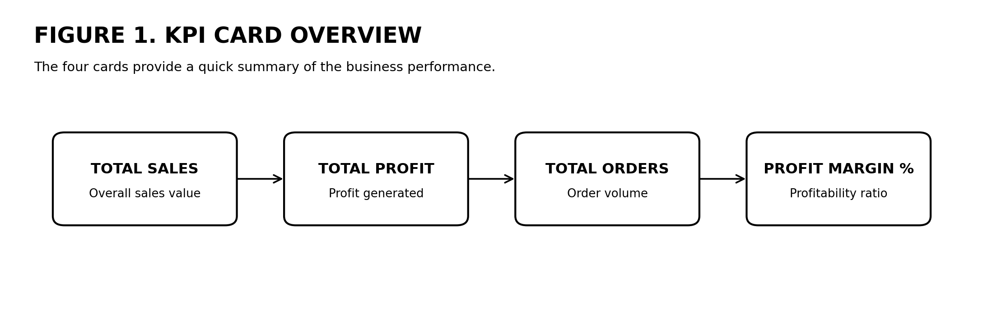
Figure 1. Four KPI cards used on the main report page.
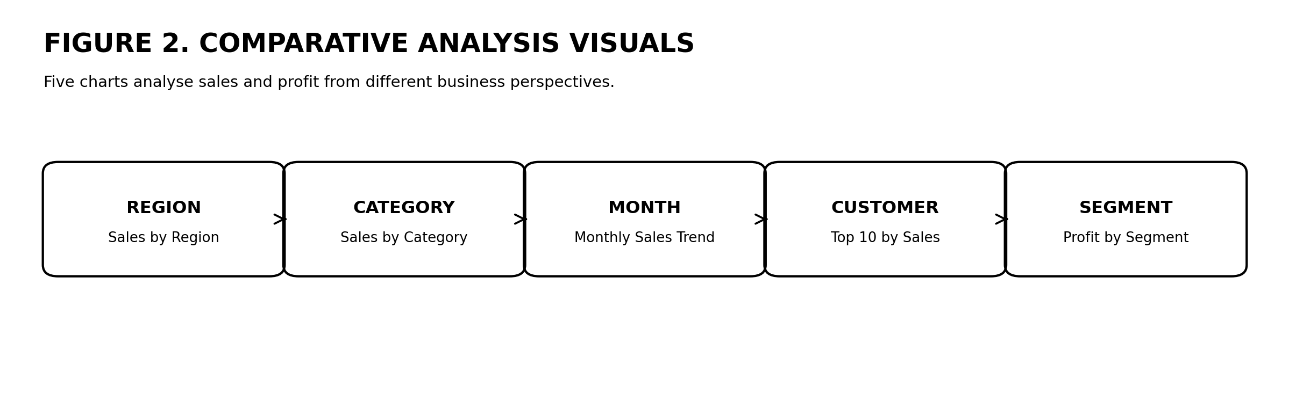
Figure 2. Five comparative-analysis visuals included on Page 1.
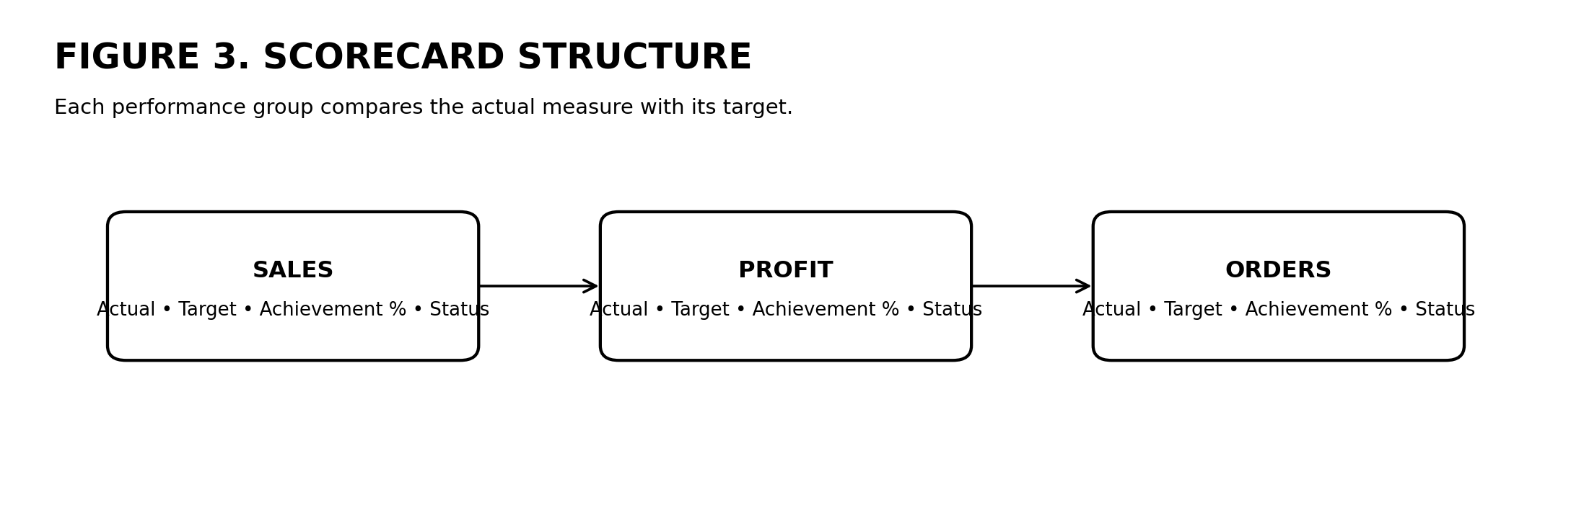
Figure 3. Sales, Profit, and Orders scorecard measure groups.
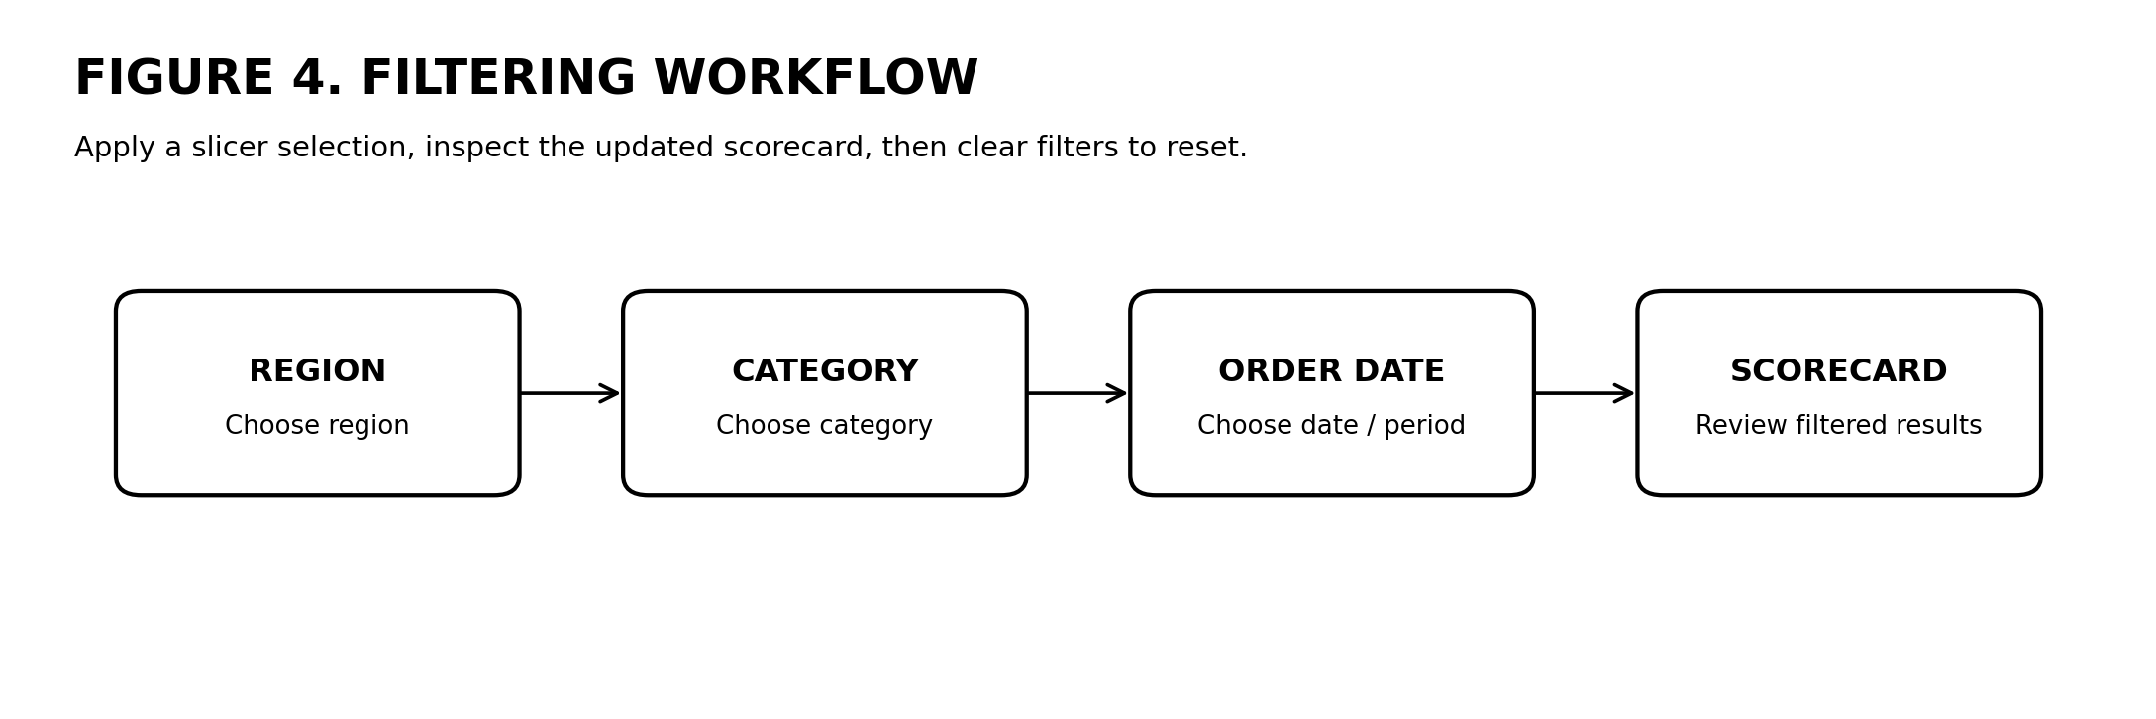
Figure 4. Region, Category, and Order Date filtering workflow.

